Photo credit: @niima316

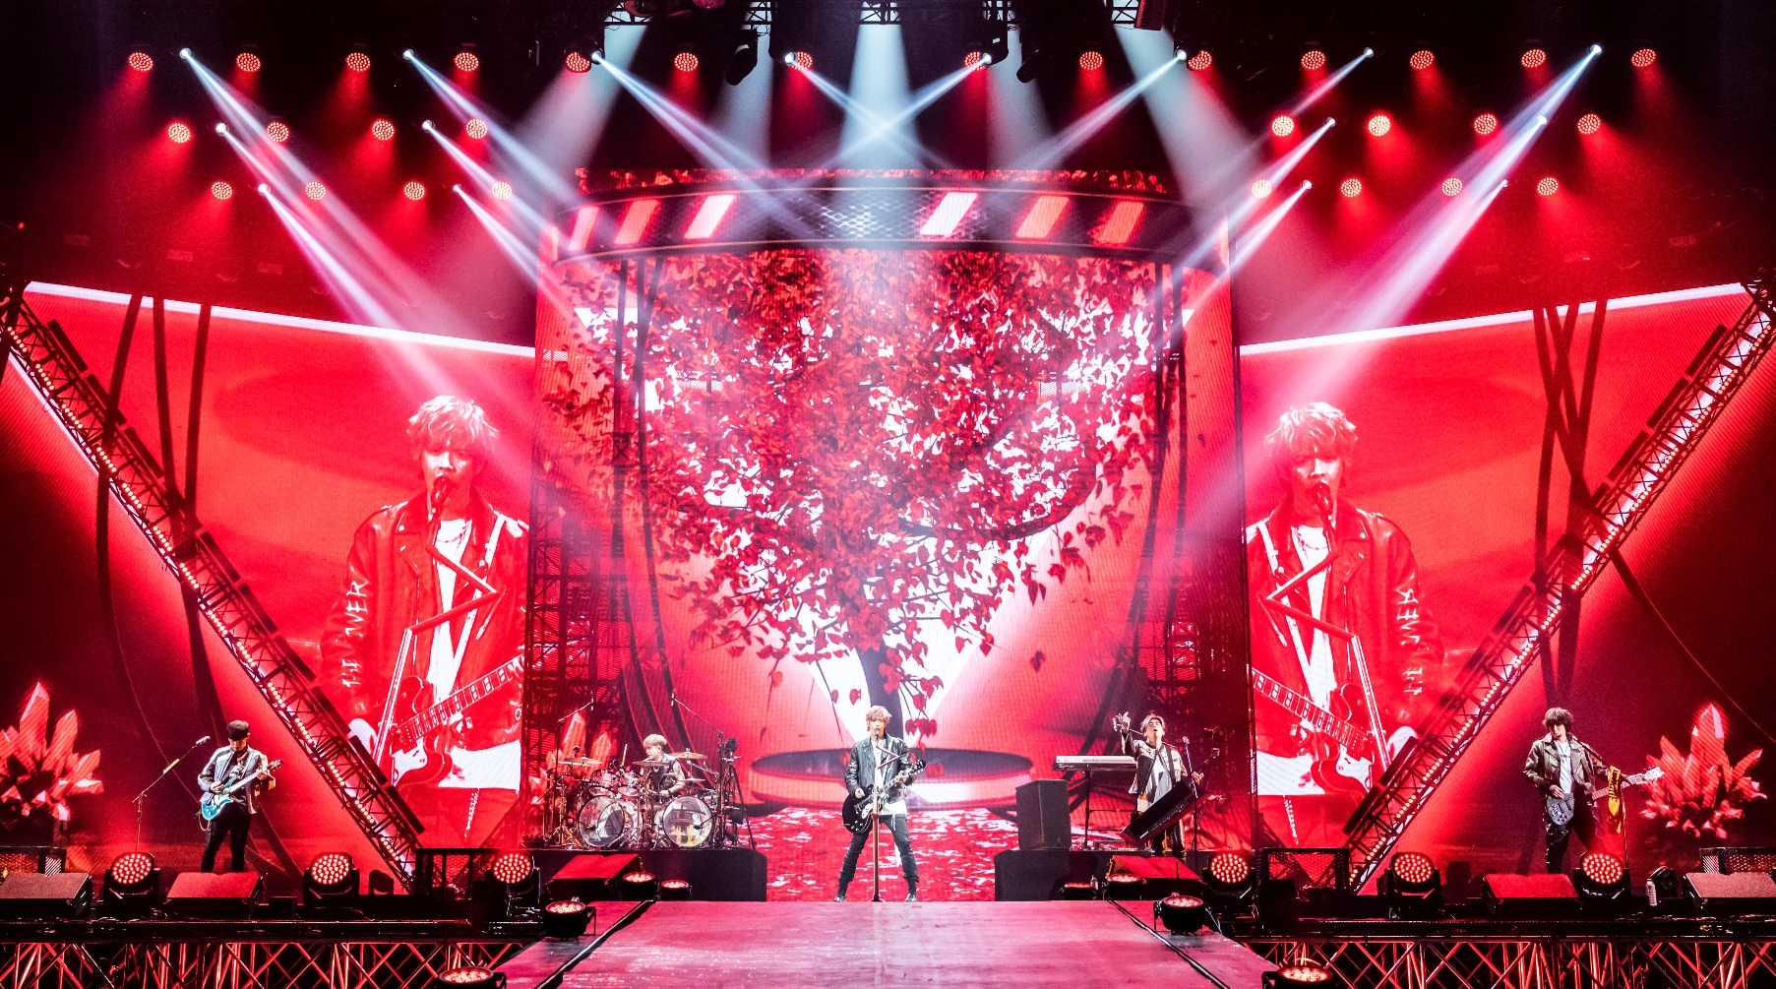
831 returns to the stage with Sennheiser Digital 6000
Taiwanese rock band makes a strong comeback with back-to-back tours across Asia

Taipei, 15 December 2022 – After a two-year hiatus due to the pandemic, Taiwanese rock band 831 (八三夭) returned to the stage with a series of sold-out concerts across Asia. The “Miss you 300” tour saw them performing 21 sold-out shows in major cities in China and a debut show in Singapore before they returned to Taiwan to kickstart their “Upside Down World” tour on home ground in the Taipei Arena. As well as giving their fans an electrifyingly good time at the shows with their beat-heavy hits, the band also shared their personal thoughts and feelings, giving fans a glimpse of their warmth behind the rocker image. Sennheiser’s Digital 6000 has always been a mainstay of 831’s touring inventory, which has gradually expanded to include many other Sennheiser and Neumann products such as the SKM 500, MD 435 and MD 445 as well as the Neumann KM 184.

When 831’s front-of-house audio engineer Huang first heard the MD 435 and MD 445 on the snare, he was so impressed that he immediately requested for it to be deployed at the Taipei concert. He also enjoys working with the Digital 6000 series for its low latency, wide dynamic range and superb sound quality.

“Sennheiser’s Digital 6000 is impressive and has been serving the band really well. In fact, it is lead vocalist Up Lee’s only choice of microphone whenever the band goes on tour,” Huang commented.

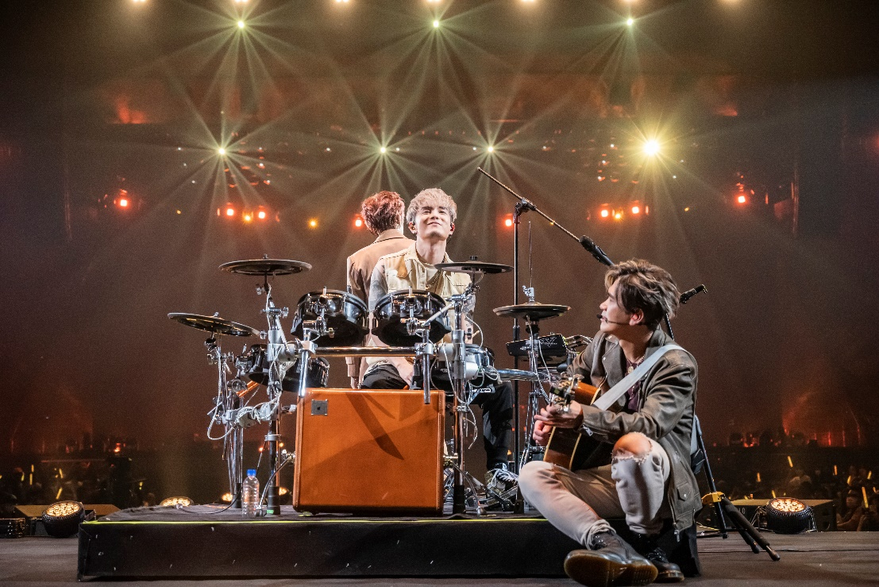
Photo credit: @niima316

For vocals, 831 used a two-channel Sennheiser Digital 6000 system. Up Lee used an SKM 6000 handheld transmitter while the rest of the band relied on the SKM 500 handhelds and SK 500 G4 wireless bodypack transmitters. Backing vocals were picked up by cabled e 935 and e 945 mics. “We are very impressed with Digital 6000’s low latency, wide dynamic range and sound quality. From an engineering perspective, D 6000 requires much less calibration and is capable of unreservedly showcasing the band’s stellar performance. It gives them the freedom and peace of mind to fully focus on their stage performance. There is no doubt why this is the vocalist’s system of choice to work with on tour,” Huang explained.

The guitar and bass were miked with wireless instrument systems from the evolution wireless series, with the drumkit benefitting from a variety of Sennheiser and Neumann microphones.
Photo credit: @niima316

The super-cardioid MD 445 was used on the snare, with its polar pattern helping to eliminate hi-hat bleed. Additionally, the e 901 and e 902 were used on the kick drum, while the toms and snare bottom were picked up by e 904 and MD 421. For the hi-hat and ride, they had chosen the Neumann KM 184.
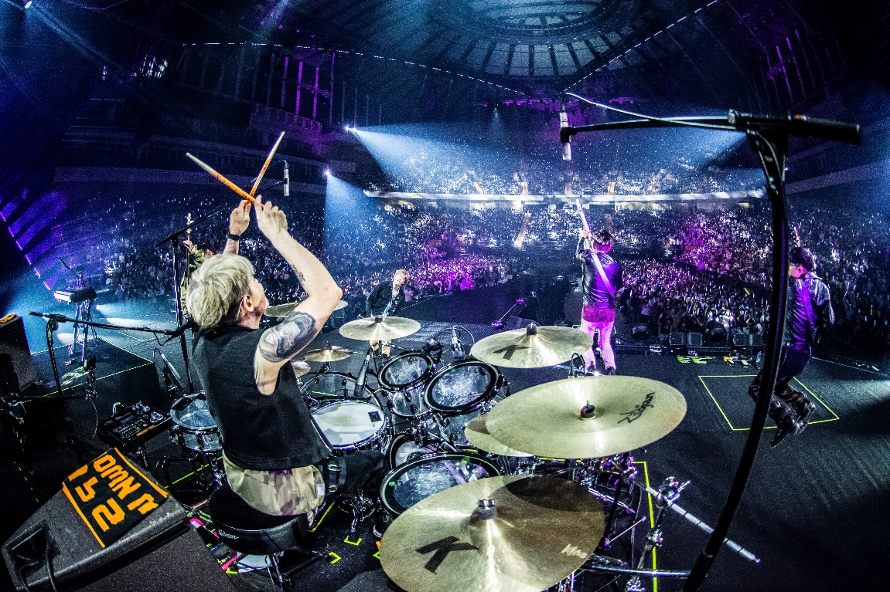
Photo credit: @niima316

Band Manager Woods Song spoke highly of the support from the local team: “I would like to thank the Sennheiser team for the great support. Our repertoire of Sennheiser and Neumann gear has grown a lot over the years. To be able to have our concert at the iconic Taipei Arena fully decked with Sennheiser and Neumann gear is a testament to how much the band love and trust the brand’s products. We look forward to continuing our journey with Sennheiser and taking our gear with us to wherever the tour takes us next!”

(Ends)

The high-resolution images accompanying this media release can be downloaded here.

About the Sennheiser brand
We live and breathe audio. We are driven by the passion to create audio solutions that make a difference. Building the future of audio and bringing remarkable sound experiences to our customers – this is what the Sennheiser brand has represented for more than 75 years. While professional audio solutions such as microphones, meeting solutions, streaming technologies and monitoring systems are part of the business of Sennheiser electronic GmbH & Co. KG, the business with consumer devices such as headphones, soundbars and speech-enhanced hearables is operated by Sonova Holding AG under the license of Sennheiser.

www.sennheiser.com
www.sennheiser-hearing.com

